**QUE-16.6- Write a map reduce program to join the below given two datasets using Reducer side join.**

**ANS-16.6-**

**Driver-**

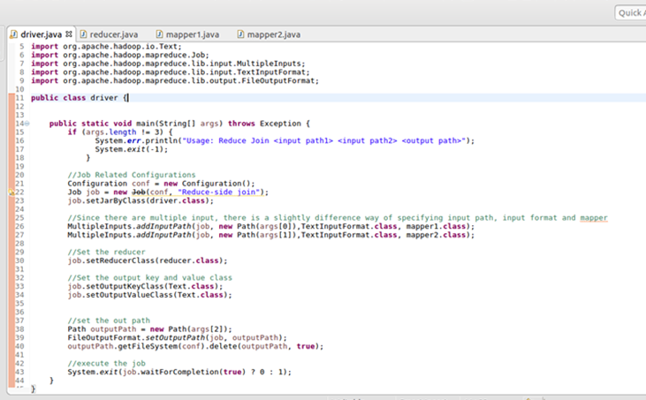

**Mapper 1-**

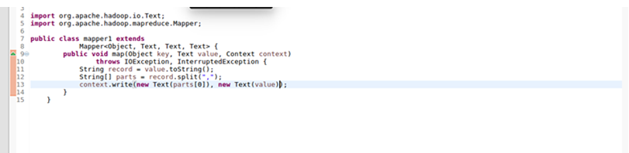

**Mapper 2-**

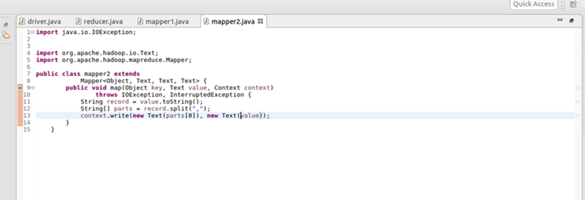

**Reducer-**

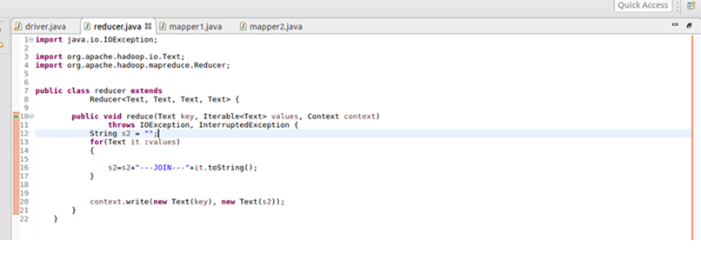

**Output-**

